**CONTROL AND COORDINATION**

Prepared by Mr. John Ebenezer

**CLASS: X BIOLOGY**

**_______________________________________________________**

**Multiple Choice Questions**

**1. Which of the following statements is correct about receptors?**

**(a) Gustatory receptors detect taste while olfactory receptors detect smell**

**(b) Both gustatory and olfactory receptors detect smell**

**(c) Auditory receptors detect smell and olfactory receptors detect taste**

**(d) Olfactory receptors detect taste and gustatory receptors smell**

**Ans.** **(a) Gustatory receptors detect taste while olfactory receptors detect smell**

**Explanation:**

A receptor is a cell which is sensitive for the external stimulus such as light, taste, smell. Ex: Photoreceptors detect light. Gustatory receptors detect taste. Olfactory receptors detect smell.

**2. Electrical impulse travels in a neuron from**

**(a) Dendrite → axon → axonal end → cell body**

**(b) Cell body → dendrite → axon → axonal end**

**(c) Dendrite → cell body → axon → axonal end**

**(d) Axonal end → axon → cell body → dendrite**

**Ans. (c) Dendrite → cell body → axon → axonal end**

**Explanation:**

Stimulus is received by dendrites which are transmitted to cell body through axon. Stimulus reaches the terminal branches called as axonal end from where they are transmitted to another neuron.

**3. In a synapse, a chemical signal is transmitted from**

**(a) dendritic end of one neuron to axonal end of another neuron**

**(b) axon to the cell body of the same neuron**

**(c) cell body to axonal end of the same neuron**

**(d) axonal end of one neuron to dendritic end of another neuron**

**Ans. (d) axonal end of one neuron to dendritic end of another neuron**

**Explanation:**

Electric impulse travels from the axon to the dendrite of another neuron through a synaptic gap which consist of SYNAPSE.

**4. In a neuron, conversion of electrical signal to a chemical signal occurs at/in**

**(a) cell body**

**(b) axonal end**

**(c) dendritic end**

**(d) axon**

**Ans.** **(b) axonal end**

**Explanation:**

At axonal end, electric impulse triggers the release of neurotransmitter. These chemicals enter dendrite of another neuron to transmit the signal.

**5. Which is the correct sequence of the components of a reflex arc?**

**(a) Receptors→ Muscles→ Sensory neuron→ Motor neuron→ Spinal cord**

**(b) Receptors→ Motor neuron → Spinal cord → Sensory neuron → Muscle**

**(c) Receptors → Spinal cord → Sensory neuron → Motor neuron → Muscle**

**(d) Receptors → Sensory neuron → Spinal cord → Motor neuron → Muscle**

**Ans.** **(d) Receptors → Sensory neuron → Spinal cord → Motor neuron → Muscle**

**Explanation:**

Sensory neurons receive signals from receptors. These signals are sent to the spinal cord which reaches Muscles through motor neuron.

**6. Which of the following statements are true?**

**(i) Sudden action in response to something in the environment is called reflex action**

**(ii) Sensory neurons carry signals from the spinal cord to muscles**

**(iii) Motor neurons carry signals from receptors to the spinal cord**

**(iv) The path through which signals are transmitted from a receptor to a muscle or a gland is called the reflex arc**

**(a) (i) and (ii)**

**(b) (i) and (iii)**

**(c) (i) and (iv)**

**(d) (i) , (ii) and (iii)**

**Ans.** **(c) (i) and (iv)**

**Explanation:**

Sensory neurons carry signals from muscles to spinal cord hence statement ii) and iv) are wrong statements.

**7. Which of the following statements are true about the brain?**

**(i) The main thinking part of the brain is the hindbrain**

**(ii) Centres of hearing, smell, memory, sight etc are located in forebrain.**

**(iii) Involuntary actions like salivation, vomiting, blood pressure are controlled by the medulla in the hindbrain**

**(iv) Cerebellum does not control the posture and balance of the body**

**(a) (i) and (ii)**

**(b) (i), (ii) and (iii)**

**(c) (ii) and (iii)**

**(d) (iii) and (iv)**

**Ans.** **(c) (ii) and (iii)**

**Explanation:**

Forebrain is the thinking part of brain hence statement i) is wrong. Cerebellum control posture and balance of the body hence statement iv) is wrong

**8. Posture and balance of the body is controlled by**

**(a) cerebrum**

**(b) cerebellum**

**(c) medulla**

**(d) pons**

**Ans.** **(b) cerebellum**

**Explanation:**

Cerebrum is responsible for sensory processing. Medulla controls involuntary functions. Pons regulates respiration and controls involuntary actions sensations such as touch and pain.

**9. Spinal cord originates from**

**(a) cerebrum**

**(b) medulla**

**(c) pons**

**(d) cerebellum**

**Ans.** **(b) medulla**

**10. The movement of shoot towards light is**

**(a) geotropism**

**(b) hydrotropism**

**(c) chemotropism**

**(d) phototropism**

**Ans.** **(d) phototropism**

**Explanation:**

Growth of plant roots towards or away from moisture is called hydrotropism. Plant growth in response to gravitational force is called as geotropism. Growth of plant in response to chemical stimulus is called chemotropism.

**11. The main function of abscisic acid in plants is to**

**(a) increase the length of cells**

**(b) promote cell division**

**(c) inhibit growth**

**(d) promote the growth of stem**

**Ans.** **(c) inhibit growth**

**Explanation:**

Auxins increase the length of cells. Cytokinins promote cell division. Gibberellins promote growth of stem.

**12. Which of the following is not associated with the growth of a plant?**

**(a) Auxin**

**(b) Gibberellins**

**(c) Cytokinins**

**(d) Abscisic acid**

**Ans.** **(d) Abscisic acid**

**Explanation:**

Abscisic acid inhibits the growth of plant hence it is not associated with the growth of the plant.

**13. Iodine is necessary for the synthesis of which hormone?**

**(a) Adrenaline**

**(b) Thyroxin**

**(c) Auxin**

**(d) Insulin**

**Ans.** **(b) Thyroxin**

**14. Choose the incorrect statement about insulin**

**(a) It is produced from pancreas**

**(b) It regulates the growth and development of the body**

**(c) It regulates blood sugar level**

**(d) Insufficient secretion of insulin will cause diabetes**

**Ans.** **(b) It regulates growth and development of the body**

**15. Select the mismatched pair**

**(a) Adrenaline: Pituitary gland**

**(b) Testosterone: Testes**

**(c) Estrogen : Ovary**

**(d) Thyroxin: Thyroid gland**

**Ans.** **(a) Adrenaline: Pituitary gland**

**Explanation:**

Adrenaline is secreted by Adrenal gland and Pituitary gland produces TSH, FSH and GSH hormones.

**16. The shape of guard cells changes due to change in the**

**(a) protein composition of cells**

**(b) temperature of cells**

**(c) amount of water in cells**

**(d) position of the nucleus in the cells**

**Ans.** **(c) amount of water in cells**

**Explanation:**

Excess of water will turn guard cells turgid and loss of water turn guard cells flaccid.

**17. The growth of tendril in pea plants is due to**

**(a) effect of light**

**(b) effect of gravity**

**(c) rapid cell divisions in tendrillar cells that are away from the support**

**(d) rapid cell divisions in tendrillar cells in contact with the support**

**Ans.** **(c) rapid cell divisions in tendrillar cells that are away from the support**

**18. The growth of pollen tubes towards ovules is due to**

**(a) hydrotropism**

**(b) chemotropism**

**(c) geotropism**

**(d) phototropism**

**Ans.** **(b) chemotropism**

**Explanation:**

Chemicals released by ovules stimulate the growth of pollen tubes towards ovules.

**19. The movement of sunflower in accordance with the path of the sun is due to**

**(a) phototropism**

**(b) geotropism**

**(c) chemotropism**

**(d) hydrotropism**

**Ans.** **(a) phototropism**

**Explanation:**

The movement of shoot towards light is called phototropism.

Plant growth in response to gravitational force is called geotropism.

Growth of plant in response to chemical stimulus is called chemotropism.

Growth of plant roots towards or away from moisture is called hydrotropism.

**20. The substance that triggers the fall of mature leaves and fruits from plants is due to**

**(a) auxin**

**(b) gibberellin**

**(c) abscisic acid**

**(d) cytokinin**

**Ans.** **(c) abscisic acid**

**Explanation:**

Abscisic acid forms a layer of abscission. This layer disconnect the living tissue of leaf from the other parts.

**21. Which of the following statements about transmission of nerve impulse is incorrect?**

**(a) Nerve impulse travels from dendritic end towards axonal end**

**(b) At the dendritic end electrical impulses bring about the release of some chemicals which generate an electrical impulse at the axonal end of another neuron**

**(c) The chemicals released from the axonal end of one neuron cross the synapse and generate a similar electrical impulse in a dendrite of another neuron**

**(d) A neuron transmits electrical impulses not only to another neuron but also to muscle and gland cells**

**Ans.** **(b) At the dendritic end electrical impulses bring about the release of some chemicals which generate an electrical impulse at the axonal end of another neuron**

**Explanation:**

Chemicals or neurotransmitters are released at axonal end not on dendritic end. Hence statement b) is incorrect

**22. Involuntary actions in the body are controlled by**

**(a) medulla in fore brain**

**(b) medulla in mid brain**

**(c) medulla in hind brain**

**(d) medulla in spinal cord**

**Ans.** **(c) medulla in hind brain**

**Explanation:**

Medulla is present only in hind brain

**23. Which of the following is not an involuntary action?**

**(a) Vomiting**

**(b) Salivation**

**(c) Heartbeat**

**(d) Chewing**

**Ans.** **(d) Chewing**

**24. When a person is suffering from severe cold, he or she cannot**

**(a) differentiate the taste of an apple from that of an ice cream**

**(b) differentiate the smell of a perfume from that of an agarbatti**

**(c) differentiate red light from green light**

**(d) differentiate a hot object from a cold object**

**Ans.** **(b) differentiate the smell of a perfume from that of an agarbatti**

**Explanation:**

During cold olfactory receptors gets blocked hence we cannot differentiate smell.

**25. What is the correct direction of flow of electrical impulses?**

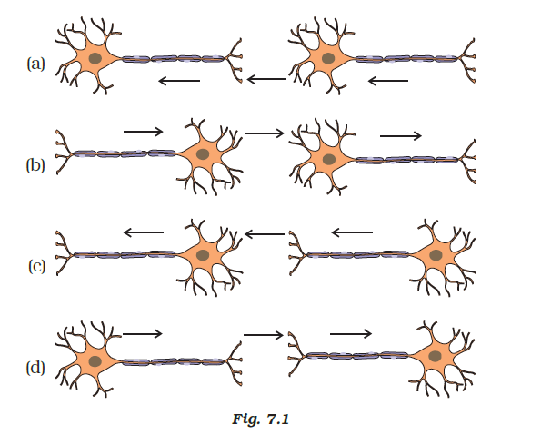

**Ans. (c)**

**Explanation:**

Dendrites of a neuron receive electrical impulse from axonal end of another neuron. After that, the electrical impulse travels through the cell body, axon; to the axonal end.

**26. Which statement is not true about thyroxin?**

**(a) Iron is essential for the synthesis of thyroxin**

**(b) It regulates carbohydrates, protein and fat metabolism in the body**

**(c) The thyroid gland requires iodine to synthesise thyroxin**

**(d) Thyroxin is also called thyroid hormone**

**Ans.** **(a) Iron is essential for the synthesis of thyroxin**

**Explanation:**

Iodine is essential for the synthesis of thyroxin but not iron hence statement a) is wrong

**27. Dwarfism results due to**

**(a) Excess secretion of thyroxin**

**(b) Less secretion of growth hormone**

**(c) Less secretion of adrenaline**

**(d) Excess secretion of growth hormone**

**Ans.** **(b) Less secretion of growth hormone**

**Explanation:**

Growth hormones are responsible for the overall growth of an organism. When there will be no secretion of growth hormones it leads to dwarfism.

**28. Dramatic changes of body features associated with puberty are mainly because of the secretion of**

**(a) oestrogen from testes and testosterone from ovary**

**(b) estrogen from adrenal gland and testosterone from pituitary gland**

**(c) testosterone from testes and estrogen from ovary**

**(d) testosterone from thyroid gland and estrogen from pituitary gland**

**Ans.** **(c) testosterone from testes and estrogen from ovary**

**Explanation:**

These are the sex hormones responsible for the secondary character that appear after puberty. Males secrete testosterone and females secrete estrogen.

**29. A doctor advised a person to take an injection of insulin because**

**(a) his blood pressure was low**

**(b) his heart was beating slowly**

**(c) he was suffering from goitre**

**(d) his sugar level in blood was high**

**Ans.** **(d) his sugar level in blood was high**

**Explanation:**

Patient suffering from diabetes will have high blood glucose due to non-functioning or lack of insulin hormone. Such patients are administered with insulin injection to regulate blood glucose.

**30. The hormone which increases the fertility in males is called**

**(a) oestrogen**

**(b) testosterone**

**(c) insulin**

**(d) growth hormone**

**Ans.** **(b) testosterone**

**31. Which of the following endocrine glands is unpaired?**

**(a) Adrenal**

**(b) Testes**

**(c) Pituitary**

**(d) Ovary**

**Ans.** **(c) Pituitary**

**Explanation:**

Adrenal glands are two which are present on top of each kidney. Testes is a paired gland in males which produces male sex hormones. Ovary is a paired gland in females which produces female sex hormones. Pituitary gland is an independent gland present below the brain. It is called as master gland as it secretes major of the hormones.

**32. The junction between two neurons is called**

**(a) cell junction**

**(b) neuromuscular junction**

**(c) neural joint**

**(d) synapse**

**Ans.** **(d) synapse**

**Explanation:**

A synapse is a structure that allows a neuron to pass an electric signal to the next neuron or effector cell. Hence it is a junction between two neurons.

**33. In humans, the life processes are controlled and regulated by**

**(a) reproductive and endocrine systems**

**(b) respiratory and nervous systems**

**(c) endocrine and digestive systems**

**(d) nervous and endocrine systems**

**Ans.** **(d) nervous and endocrine systems**

**Explanation :**

Reproductive, respiratory and digestive systems have no role to play in control and regulation of life processes. It is the nervous system and the endocrine system that control and regulates all the processes including Reproductive, respiratory and digestive systems.

**Following questions consist of two statements – Assertion (A) and Reason (R). Answer these questions selecting the appropriate option given below:**

(a) Both A and R are true and R is the correct explanation of A.  
(b) Both A and R are true but R is not the correct explanation of A.  
(c) A is true but R is false.  
(d) A is false but R is true.

**1. Assertion(A) :** Insulin regulates blood sugar level.  
**Reason (R) :**Insufficient secretion of insulin will cause diabetes.

Answer (a) Both A and R are true and R is the correct explanation of A.

**2. Assertion(A) :**Animals can react to stimuli in different ways.  
**Reason (R) :** All animals have a nervous system and an endocrine system involving hormones.

Answer (a) Both A and R are true and R is the correct explanation of A.

**3. Assertion(A):**The effect of auxin hormone on the growth of root is exactly opposite to that on a stem.  
**Reason (R) :**Auxin hormone increases the rate of growth in root and decreases the rate of growth in stem.

Answer (c) A is true but R is false.

**4. Assertion(A):**A receptor is a specialized group of cells in a sense organ that perceive a particular type of stimulus.  
**Reason (R) :** Different sense organs have different receptors for detecting stimuli.

Answer (b) Both A and R are true but R is not the correct explanation of A.

**5. Assertion(A):**Cyton region of nerve fibre collects information for the brain.  
**Reason (R):** Nerve fibres can either have or lack myelin sheath.

Answer (d) A is false but R is true.

**6. Assertion(A):** A nerve impulse is an electrochemical event.  
**Reason (R) :**In a nerve impulse there are changes in the resting potential which spreads down the nerve fibre.

Answer (a) Both A and R are true and R is the correct explanation of A.

**7. Assertion(A) :**The brain is also known as the central nervous system.  
**Reason (R) :** Central nervous system controls and regulates the voluntary actions.

Answer (d) A is false but R is true.

**8. Assertion(A) :**The spinal nerves are 31 in number.  
**Reason (R) :**Spinal nerves only have sensory neurons in them

Answer (c) A is true but R is false.

**1. Label the parts (a), (b), (c) and (d) and show the direction of flow of electrical signals in Figure 7.2.**

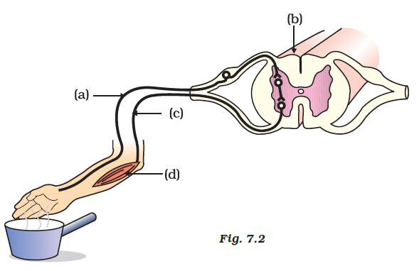

**Ans:**

1. **Sensory neuron**
2. **Spinal cord**
3. **Motor neuron**
4. **Muscle**

**2. Label the parts of a neuron in Figure 7.5.**

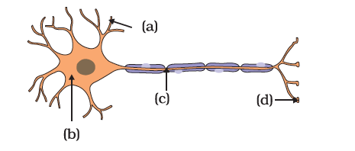

**Ans:**

1. Dendrite
2. Cell body
3. Axon
4. Axon terminal